Shift2Rail to offer its vision for a future sustainable transport system at the World Rail Festival

September 30, 2019

Category: [Latest News](https://shift2rail.org/news/), [newsletter9](https://shift2rail.org/newsletter9/)

**World Rail Festival from 3-5 December in Amsterdam will bring together over 200 high-level speakers and more than 900 attendees to discuss on the most actual topics in the rail sector. Our Head of R&I Giorgio Travaini will give a keynote on how to bring the sector together to shape a future sustainable transport system.**

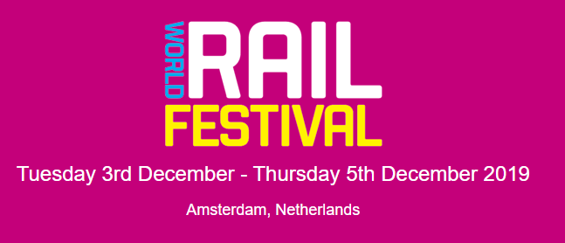

During the three-day World Rail Festival, speakers from all over the rail sector will be discussing on a variety of relevant topics including the commercial strategy, digital transformation, next generation ticketing, customer experience, revenue management, MaaS and smart mobility, stations, connectivity and real time information in the rail, bus and urban mobility sectors. Shift2Rail’s Head of Research & Innovation Giorgio Travaini will be joining a panel discussion on how operators, governments and disruptors can work effectively together to shape a future transport mix which is accessible, sustainable and simple. In the panel discussion, Mr. Travaini will share Shift2Rail’s experience in bringing the rail stakeholders together through research and innovation that moves the whole mobility sector towards a more sustainable, accessible and simple future.

In addition to the conference, the World Rail Festival will include an exhibition area where companies working in the mobility sector can showcase their work. The exhibition area will also have a dedicated space for start-ups that have a unique opportunity to participate to the event free of charge to meet key stakeholders in the mobility sector.

[Don’t miss out on the fascinating discussions on the future of mobility and register to the festival now here.](https://secure.terrapinn.com/V5/step1.aspx?E=10060&p=1&_ga=2.182524582.149738958.1569416284-1500968085.1567590467)